CryptoCore HMI Technical Manual

CryptoCore OTTOcontrol Software Version: 1.1.1

June 15, 2022

Part Number: D-RES-00004

1.0 Operation 3

1.1 CryptoCore HMI Screen Descriptions 4

1.1.1 OTTOcontrol On-screen keyboard 5

1.1.1.1 Alpha-numeric keyboard 5

1.1.1.2 Numeric keyboard 5

1.1.2 Unlock the OTTOcontrol User Interface 6

1.1.3 CryptoCore OTTOControl Default Dashboard 7

1.1.4 CryptoCore Dashboard Status 8

1.1.4.1 Status Notifications 8

1.1.4.2 Current Status Alerts and History of Cleared Alerts 9

1.1.4.4 Trip Primary Breaker 10

1.1.4.5 Alarm Threshold Parameter Values 11

1.1.4.6 CryptoCore OTTOcontrol Alarm Types 14

1.1.5 CryptoCore Health 15

1.1.6 CryptoCore Settings 16

1.1.6.1 Network Settings 17

1.1.6.1.1 Configure CryptoCore Network Settings to use DHCP 17

1.1.6.1.2 Manually configure CryptoCore Network settings 18

1.1.6.2 Alarm Settings 19

1.1.6.3 System Properties 20

1.1.6.4 Lockscreen Password 22

1.1.6.5 System Information 23

2.0 Hardware Stack 24

2.0.1 Hardware Details 25

2.0.2 Raspberry Pi I/O 26

2.0.3 PDU Master Switch 28

3.0 Troubleshooting 29

3.0.1 System State and LED State 29

Addendum A – Software Installation and Upgrade 30

Addendum B – Intellectual Property Rights 30

## 1.0 Operation

CryptoCore OTTOControl is the Human Machine Interface (HMI) software used to manage and monitor high performance, single-phase liquid cooling CryptoCore units developed for the purpose of maximizing profitability of cryptocurrency mining operations. OTTOcontrol provides functionality for managing, monitoring, and diagnosing CryptoCore units in real time. This document describes the functionality of CryptoCore OTTOcontrol and is intended for use by factory authorized service technicians.

## 1.1 CryptoCore HMI Screen Descriptions

The following ‘Locked Dashboard’ screen is displayed when a CryptoCore unit is first started. This program is running on Ubuntu Linux and can be said to be running in ‘kiosk’ mode because it does not provide access to the underlying operating system. The top section of the dashboard is displayed on all the dashboard screens and includes a Status icon , a unique machine identifier value and the current date and time.

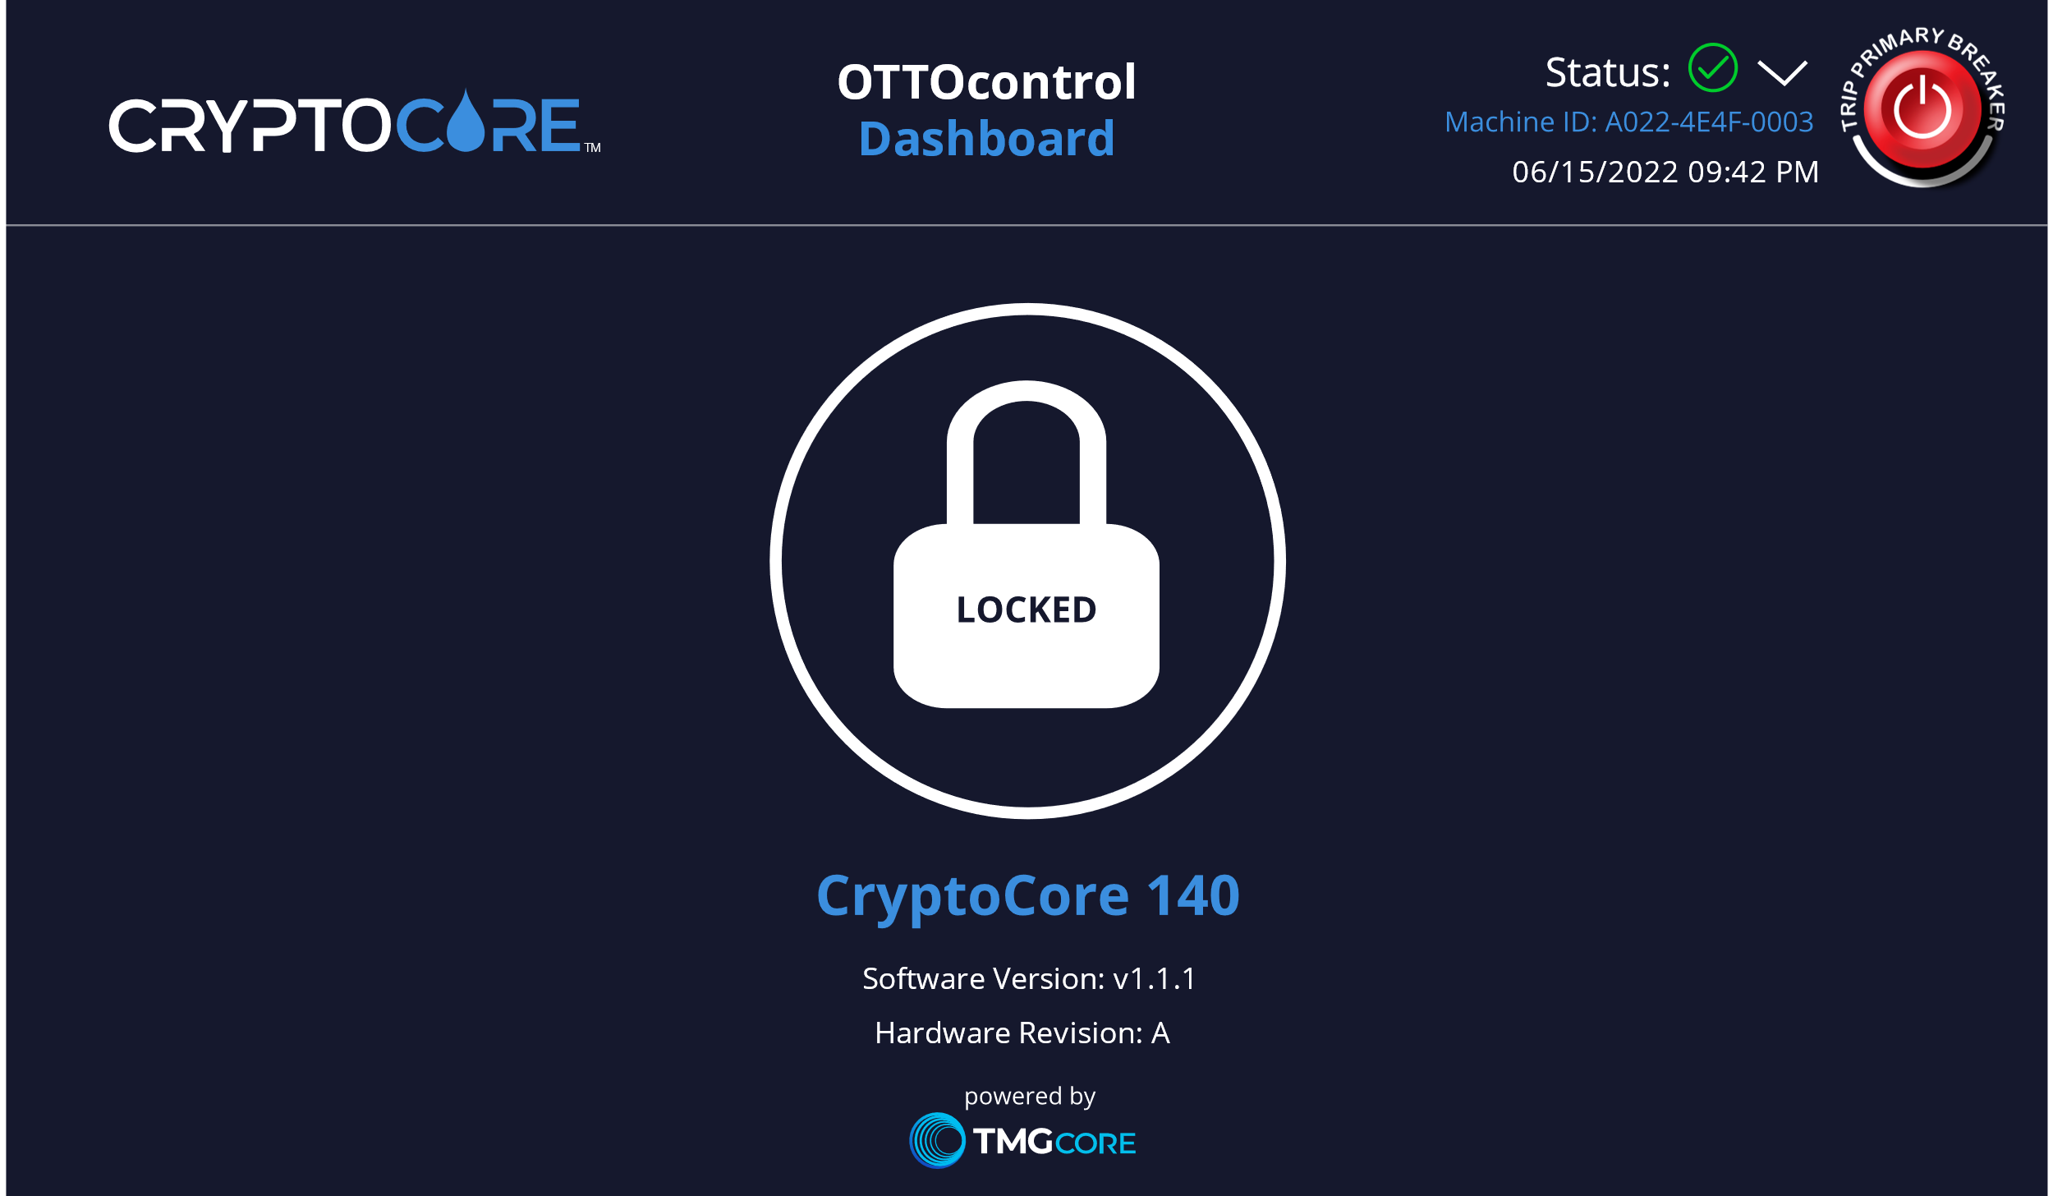*Figure 1*

### 1.1.1 OTTOcontrol On-screen keyboard

The OTTOcontrol Dashboard automatically displays an on-screen keyboard that enables users to input data when requested from various pages in the OTTOcontrol HMI. The on-screen keyboard may be alpha-numeric or number only, depending on what data is being requested from the user. The following images depict each of these keyboards:

#### 1.1.1.1 Alpha-numeric keyboard

The Alpha-numeric keyboard is displayed by the OTTOcontrol dashboard to enable users to input alpha-numeric data:

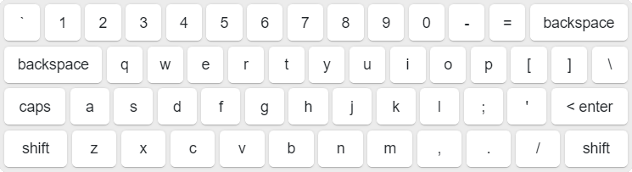 *Figure 2*

#### 1.1.1.2 Numeric keyboard

The numeric keyboard is displayed by the OTTOcontrol dashboard to enable users to input numeric data:

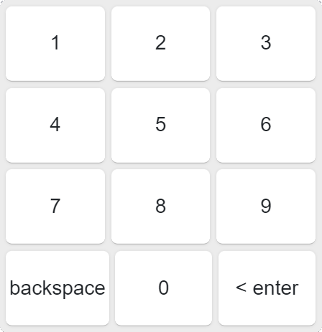

*Figure 3*

### 1.1.2 Unlock the OTTOcontrol User Interface

The lower portion of the ‘Locked Dashboard’ screen displays the lock status, Machine ID, OTTOcontrol Software Version and Hardware Revision. Follow these steps to unlock the dashboard.

1. Press the Lock icon to display an unlock icon and a password entry box.
2. Enter the correct password into the password field.
3. The password can use any combination of the following characters:

a-z,A-Z,0-9,!@#$%^&*()-=[];',./+_{}|:"?`~

For more information about the password see **Lockscreen Password**.

1. Press the unlock icon  .
2. The CryptoCore OTTOcontrol dashboard will be displayed.

### 1.1.3 CryptoCore OTTOControl Default Dashboard

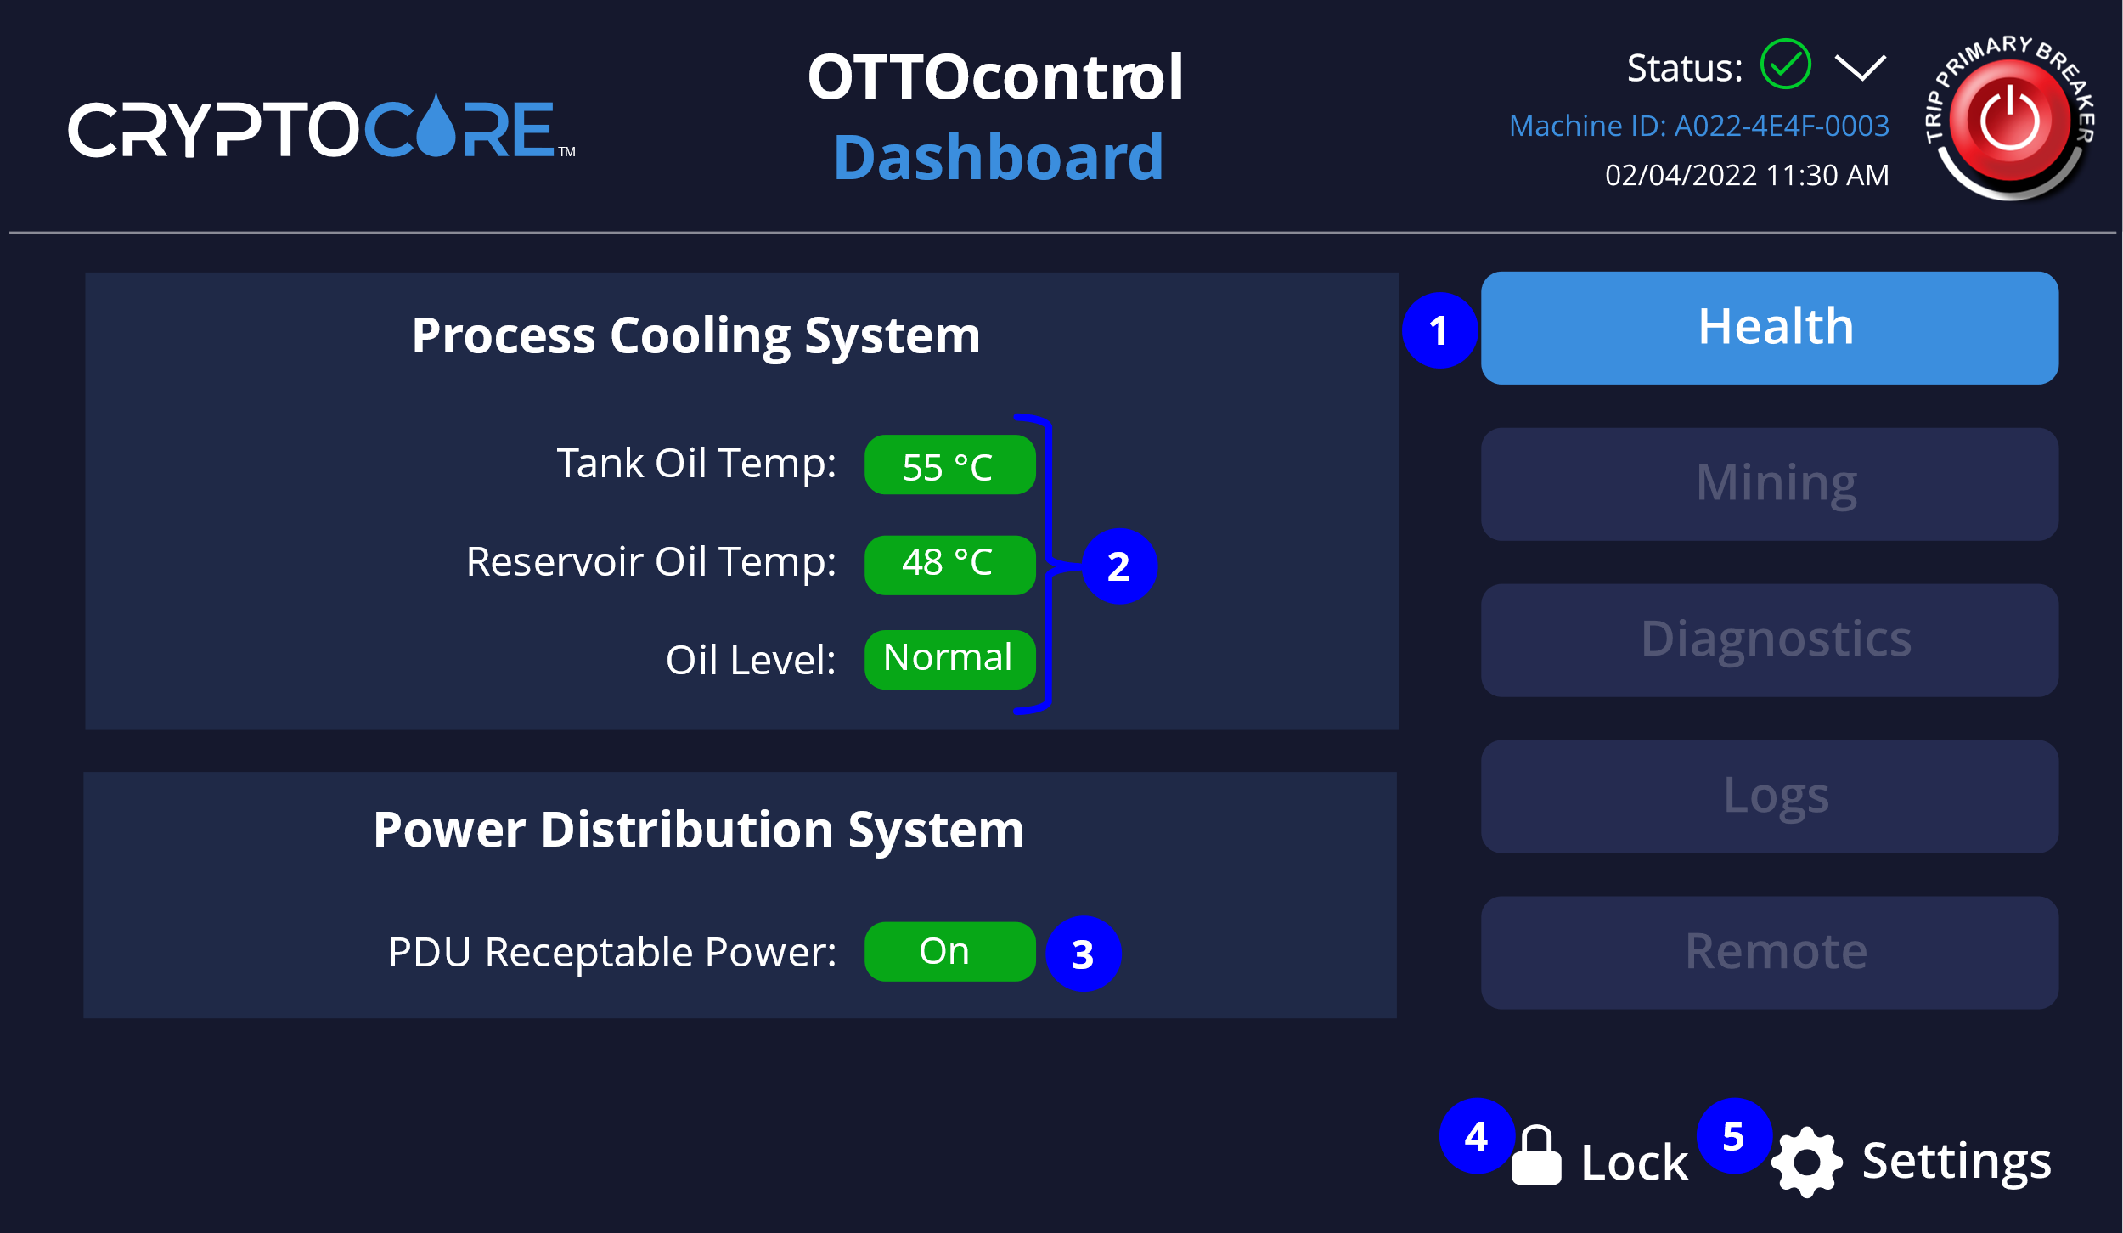The following screen is displayed after you unlock the Dashboard:

*Figure 4*

Each of the numbered items is described in further detail below:

1. **Health button** – Select to display key health metrics for the CryptoCore OTTOcontrol hardware and software. For more information see **CryptoCore Health**.
2. **Process Cooling System** – Provides an overview of key cooling metrics for the CryptoCore unit.
3. **Power Distribution System -** Indicates whether the PDU receptacle which powers the Miners is on or off
4. **Lock icon** – Click to lock the CryptoCore Dashboard and display the Dashboard Lock screen. Follow the steps at **Unlock the OTTOcontrol User Interface** to unlock the dashboard.
5. **Settings** – Click to display the **Settings Menu**.

### 1.1.4 CryptoCore Dashboard Status

The CryptoCore Dashboard displays alert icons and messages if the OTTOcontrol software detects a condition that requires investigation. Alerts are indicated by the type of icon displayed to the right of Status, in the upper-right of the Dashboard. Under normal operations, this icon is a green circle with a check mark  .

#### 1.1.4.1 Status Notifications

If the OTTOcontrol system detects a condition that requires attention, an alarm is raised and the icon displayed to the right of 'Status', in the upper-right of the Dashboard changes from a green check mark to an orange triangle with an exclamation mark for a Major alarm or a red triangle with an exclamation mark for a critical alarm. For more information about alarm types see **CryptoCore OTTOcontrol Alarm Types**.



*Figure 5*

#### 1.1.4.2 Current Status Alerts and History of Cleared Alerts

A drop-down menu is displayed to the right of the alert icon. Select the dropdown to see a brief description of active status alerts under **Current Alerts**. View a historical record of up to the last 100 cleared status alerts under the **Alerts History** section of this menu.

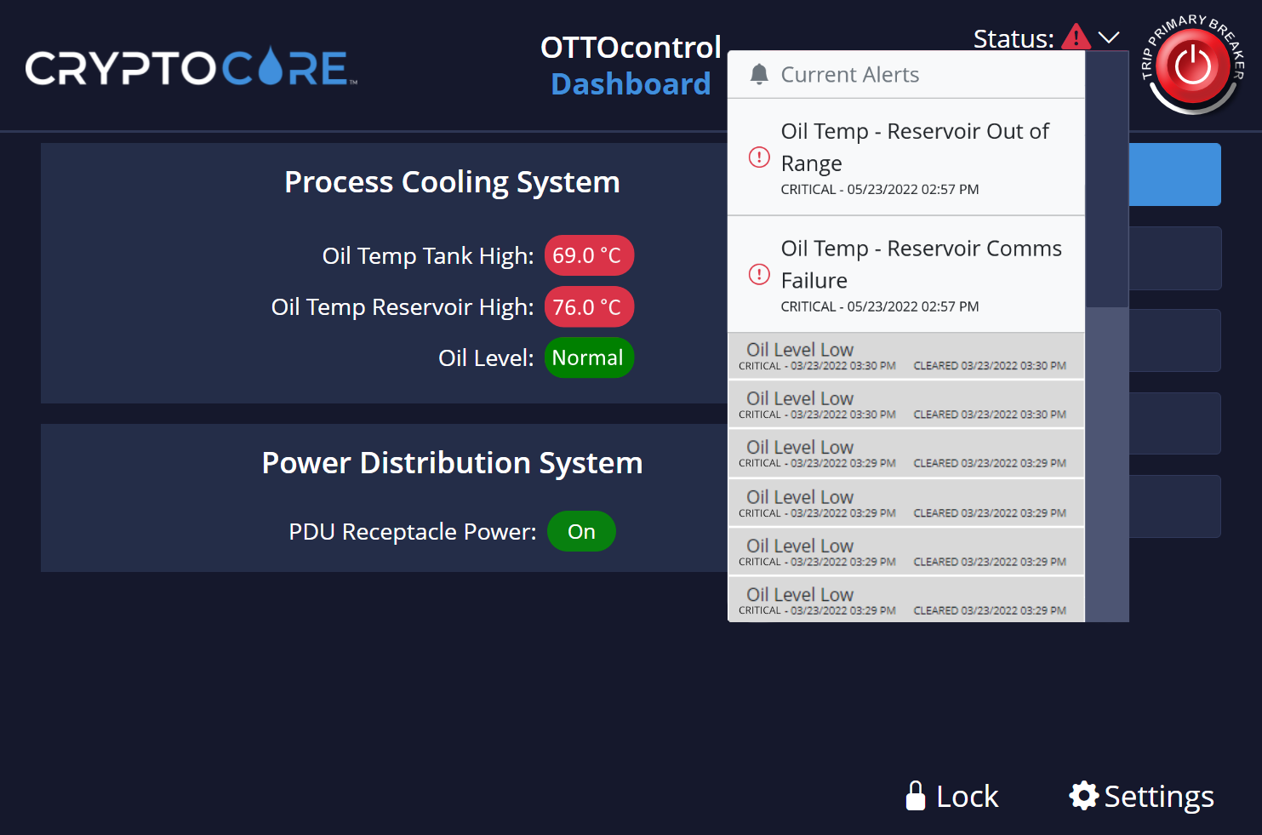*Figure 6*

#### 1.1.4.4 Trip Primary Breaker

When a CryptoCore unit encounters a critical alarm condition, power to the PDU receptacles is shut off to protect miner hardware from potential damage. Power to the PDU receptacles can also be shut down manually by:

* Turning the PDU Master Switch mounted on the CryptoCore unit from the **On** position to the **Off** position.
* Clicking the **TRIP PRIMARY BREAKER** button in the upper right corner of the OTTOcontrol dashboard.

When you click the **TRIP PRIMARY BREAKER** button, the following dialog box is displayed in the OTTOcontrol dashboard:

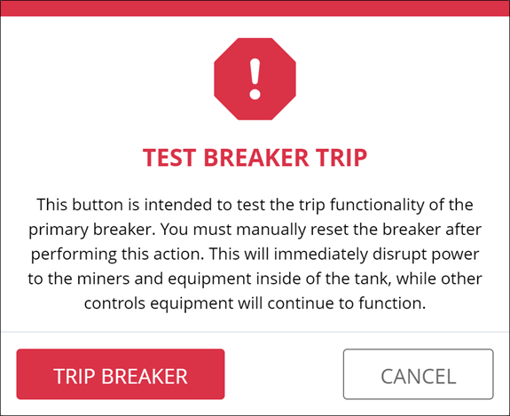

*Figure 7*

As indicated by the dialog box, if the breaker is tripped, all power to the miner hardware is turned off. However, power to the controls system is maintained so you can still manage your CryptoCore unit from the OTTOcontrol HMI.

#### 1.1.4.5 Alarm Threshold Parameter Values

The following table describes the alarm conditions that can be triggered by the CryptoCore OTTOcontrol software:

|  |  |  |  |  |  |  |
| --- | --- | --- | --- | --- | --- | --- |
| **Alarm / Condition** | **Cause** | **Remedy** | **Holdoff Time** | **Ack / Clear Method** | **LED State** | **Severity** |
| Oil Temp – Tank Comms Failure | Communication failure has occurred with one or more critical system components. | * Review logs for possible cause of error. * Resolve issue. * Restoring power to the PDU receptacles requires manually resetting the PDU master switch. * Alarms are cleared on system restart. * Alarm is recorded in Alarm history. | 30 sec | Self-cleared | Red Flashing | Critical |
| Oil Temp – Tank Out of Range | Reported values are outside of the expected range. | * Review logs for possible cause of error. * Resolve issue. * Restoring power to the PDU receptacles requires manually resetting the PDU master switch. * Alarms are cleared on system restart * Alarm is recorded in Alarm history | 30 sec | Self-cleared | Red Flashing | Critical |
| Oil Temp – Reservoir Comms Failure | Communication failure has occurred with one or more critical system components. | * Review logs for possible cause of error. * Resolve issue. * Restoring power to the PDU receptacles requires manually resetting the PDU master switch. * Alarms are cleared on system restart. * Alarm is recorded in Alarm history. | 30 sec | Self-cleared | Red Flashing | Critical |
| Oil Temp – Reservoir Out  of Range | Reported values are outside of the expected range. | * Review logs for possible cause of error. * Resolve issue. * Allow the system to cool before restarting, the system should cool to a temperature below the specified alarm threshold. * Restoring power to the PDU receptacles requires manually resetting the PDU master switch. * Alarms are cleared on system restart * Alarm is recorded in Alarm history | 30 sec | Self-cleared | Red Flashing | Critical |
| Oil Level Low | Oil level too low for safe operations. | * Check for leaks. * Add oil to the unit per the CryptoCore Maintenance Manual. * The PDU Master Switch must be reset manually on the unit to restore power to the PDU receptacles. * The alarm will clear when the condition has been resolved and the unit is operating within system parameters. * Alarm will be recorded in the alarm history. * The alarm is also cleared on system restart. | 0 Sec for LED light  30 Sec to trip PDU breaker | Self-cleared | Red Flashing | Critical |
| Oil Temp -Reservoir High | Reservoir High Oil temp exceeds maximum operating threshold. | * Investigate the cause of overheating. * The alarm will clear when the condition has been resolved and the unit is operating within system parameters. * Alarm will be recorded in the alarm history. * The alarm is also cleared upon system restart. | 30 Sec | Self-cleared | Orange | Major |
| Oil Temp -Reservoir High | Reservoir High Oil temp exceeds maximum operating threshold. This alarm is an escalation of the Major alarm with the same name. | * Investigate the cause of overheating. * Allow the system to cool before restarting. * Power to PDU receptacles is cut immediately upon raising the alarm via the PDU Master Switch. * The alarm will clear when the condition has been resolved and the unit is operating within system parameters. * PDU Master Switch must be manually reset to restore power to PDU receptacles * Alarm will be recorded in the alarm history. * The alarm is also cleared upon system restart. | 30 Sec | Self-cleared | Red Flashing | Critical |

*Table 1*

1.1.4.5 Alarm Threshold Parameter Values (continued)

|  |  |  |  |  |  |  |
| --- | --- | --- | --- | --- | --- | --- |
| **Alarm / Condition** | **Cause** | **Remedy** | **Holdoff Time** | **Ack / Clear Method** | **LED State** | **Severity** |
| Oil Temp - Tank High | Oil temperature in Miner tank exceeds specified maximum operating threshold. | * Investigate the cause of overheating. * The alarm will self-clear when the condition has been resolved and the unit is operating within system parameters. * Alarm will be recorded in the alarm history. * Alarm is cleared upon system restart | 30 Sec | Self-cleared | Orange | Major |
| Oil Temp - Tank High | Oil temperature in Miner tank exceeds specified maximum operating threshold. | * Investigate the cause of overheating. * Allow the system to cool before restarting. * Power to PDU receptacles is cut immediately upon raising the alarm via the PDU Master Switch. * The alarm will self-clear when the condition has been resolved and the unit is operating within system parameters. * Alarm will be recorded in the alarm history. * PDU Master Switch must be manually reset to restore power to PDU receptacles * Alarm is cleared upon system restart. | 30 Sec | Self-cleared | Red Flashing | Critical |

*Table 1 (cont.)*

#### 1.1.4.6 CryptoCore OTTOcontrol Alarm Types

OTTOcontrol Alarm types are described in the following table:

|  |  |
| --- | --- |
| **OTTOcontrol Alarm Type** | **Description** |
| Critical | A Critical alarm is thrown under conditions that risk safety or immediately impact service. Critical alarms require immediate attention. Running mode is turned off and PDU contactors are opened. The switch must be manually reset on the unit to restore power to the PDU receptacles. Critical alerts can be identified by a red triangle with an exclamation mark  in the upper right corner of the OTTOcontrol dashboard. |
| Major | A Major alarm is thrown when service is imminently threatened, and immediate attention is recommended. Major alerts can be identified by an orange triangle with an exclamation mark  in the upper right corner of the OTTOcontrol dashboard. |
| Minor | Minor alarms indicate a warning. Service is not immediately affected however conditions may deteriorate and lead to a major or critical alarm. |
| Informational | Informational alarms provide information only and do not require immediate attention. |

*Table 2*

### 1.1.5 CryptoCore Health

Select the **Health** button from the **OTTOcontrol Default Dashboard** to show the value of various parameters that indicate the health of the OTTOcontrol software and associated hardware. A healthy parameter value is indicated by a green checkmark  , an unhealthy parameter is indicated by a red exclamation mark  . A screen like the following is displayed when you click the **Health** button.

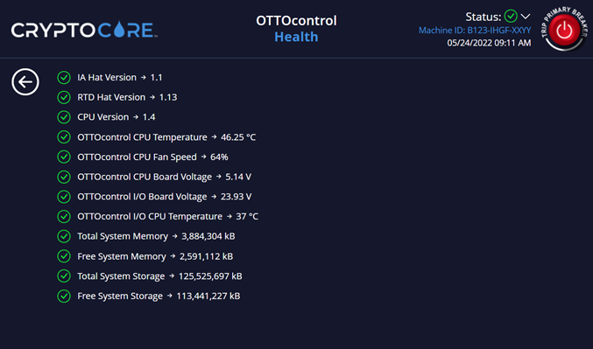

*Figure 8*

Each of these items is described in further detail below:

1. **IA Hat Version** – Version of the Industrial Automation (IA) HAT module.
2. **RTD Hat Version** – Version of the Resistance Temperature Detector (RTD) HAT module.
3. **CPU Version** – Version of Raspberry Pi CPU
4. **OTTOcontrol CPU Temperature** – Temperature of the Raspberry Pi CPU
5. **OTTOcontrol CPU Fan Speed** – Speed of Raspberry Pi CPU Fan
6. **OTTOcontrol CPU Board Voltage** – Voltage of the CPU board
7. **OTTOcontrol I/O Board Voltage** – Voltage of the CPU I/O board
8. **OTTOcontrol I/O CPU Temperature** – Temperature of the CPU
9. **Total System Memory** – Total accessible computer memory
10. **Free System Memory** – Total available computer memory
11. **Total System Storage** – Total accessible computer storage
12. **Free System Storage** – Total available computer storage

### 1.1.6 CryptoCore Settings

The **Settings** menu for the CryptoCore dashboard is accessible by clicking the gear icon next to **Settings** at the bottom right of the CryptoCore dashboard. Clicking the gear icon opens a menu that contains several CryptoCore configuration options that must be applied before your CryptoCore unit is operational.

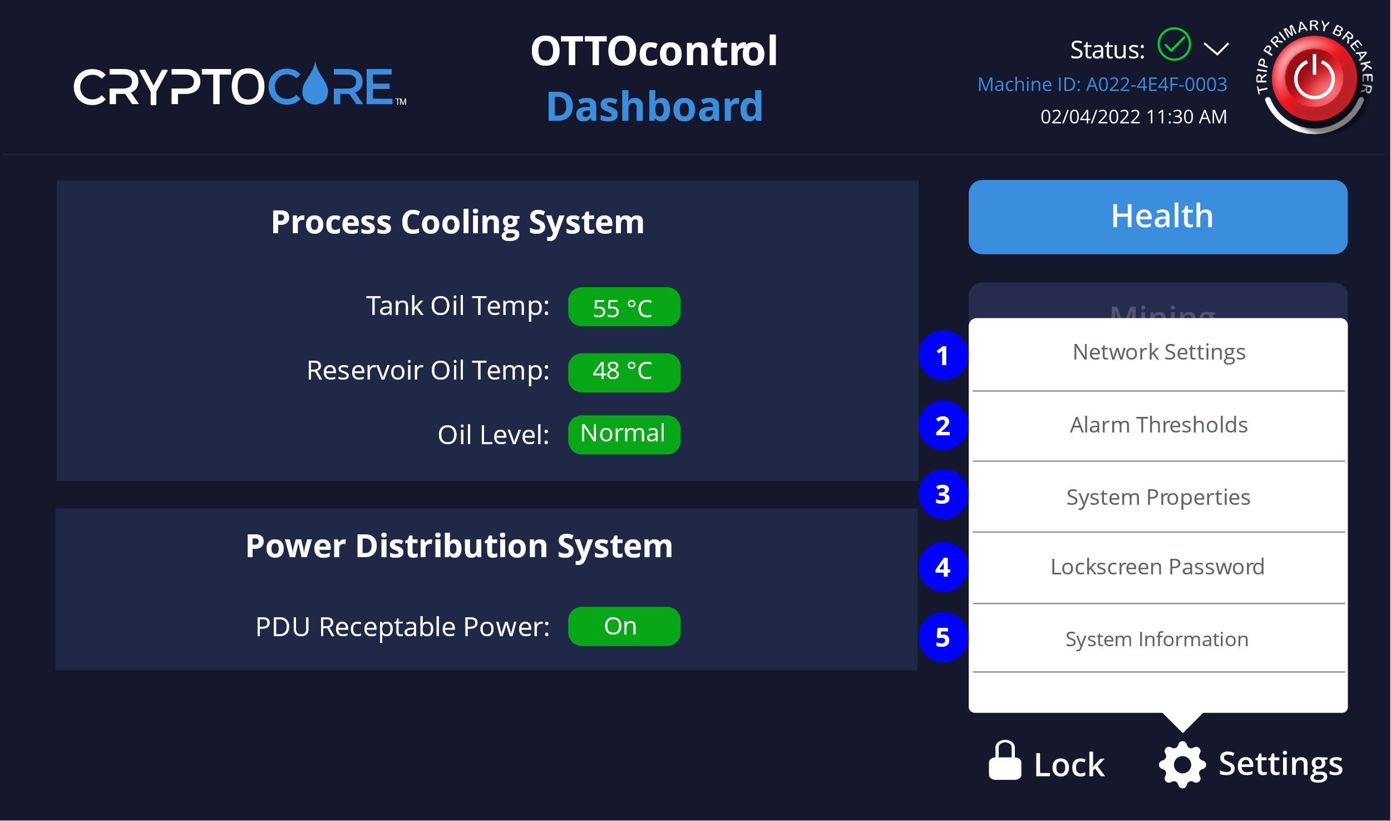

*Figure 9*

Each of the numbered items is referenced below:

1. **Network Settings**
2. **Alarm Settings**
3. **System Properties**
4. **Lockscreen Password**
5. **System Information**

#### 1.1.6.1 Network Settings

Select **Settings** and then **Network Settings** to enter the TCP/IP v4 network configuration required for connecting your CryptoCore unit to the local network.

##### 1.1.6.1.1 Configure CryptoCore Network Settings to use DHCP

If you enable the **DHCP** option, your CryptoCore unit will search the local network for a DHCP server to provide a valid TCP/IP v4 network configuration. Once a valid network configuration is received, the CryptoCore unit will have access to the local TCP/IP network. To apply DHCP settings enter the system password and click **Apply**.

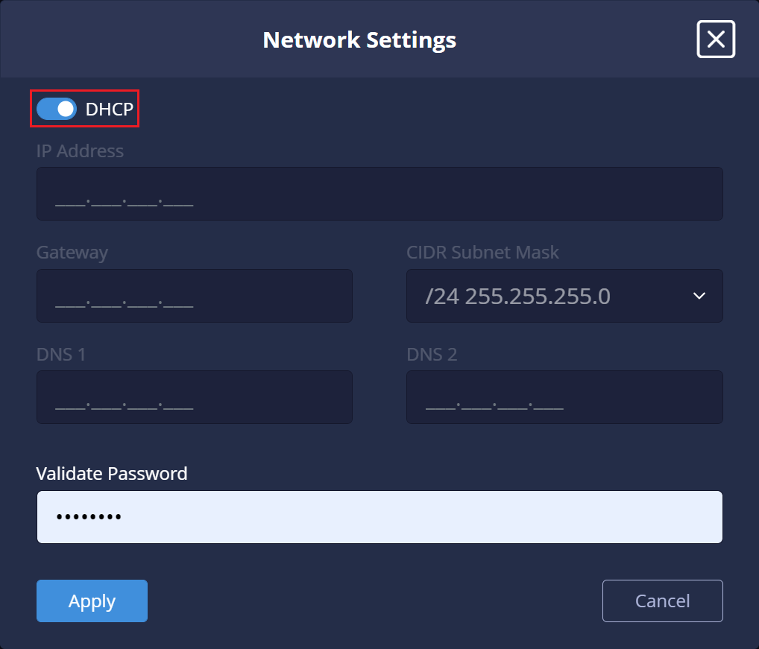*Figure 10*

##### 1.1.6.1.2 Manually configure CryptoCore Network settings

To manually configure network settings, leave the DHCP option disabled and manually enter TCP/IP configuration parameters in the **Network Settings** dialog box. Click **Save** to apply the network configuration.

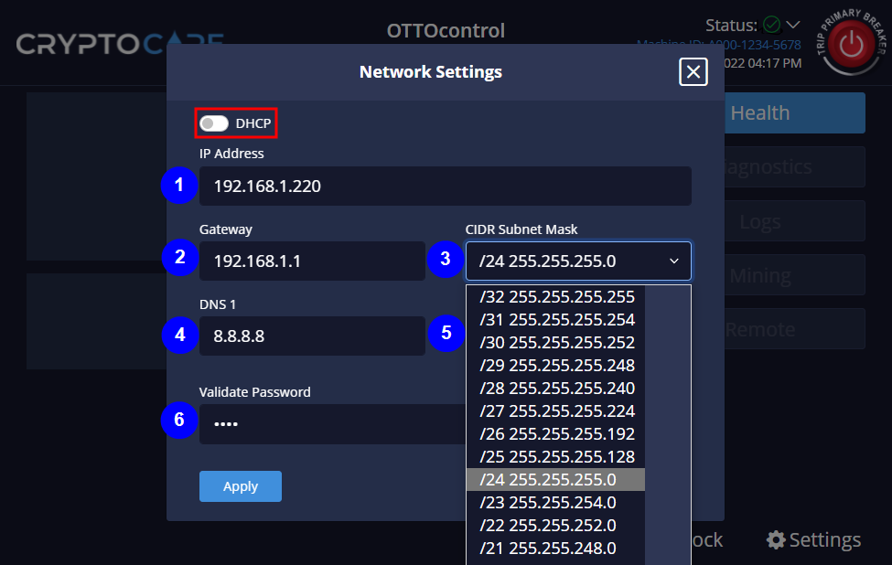*Figure 11*

Each of the numbered items is described in further detail below:

1. **IP Address** – enter a valid TCP/IP address for your local network.
2. **Gateway** – Enter a valid TCP/IP address of the default gateway for your local network.
3. **Subnet Mask value** – Select CIDR Subnet Mask value.
4. **DNS 1** – Enter TCP/IP address of DNS server.
5. **DNS 2** – Enter TCP/IP address of backup DNS server (Field obscured by CIDR Subnet Mask dropdown)
6. **Validate Password** – To apply network settings enter the system password and click **Apply**.

**Note**

Consult with your Network administrator when setting these values. Particular CIDR values (such as /28 - /32) will limit the number of usable miner host addresses in the same subnet to 14 or less when applying the generally accepted formula of available host addresses – 2.

#### 1.1.6.2 Alarm Settings

Select **Settings** and then **Alarm Settings** to change Alarm settings.

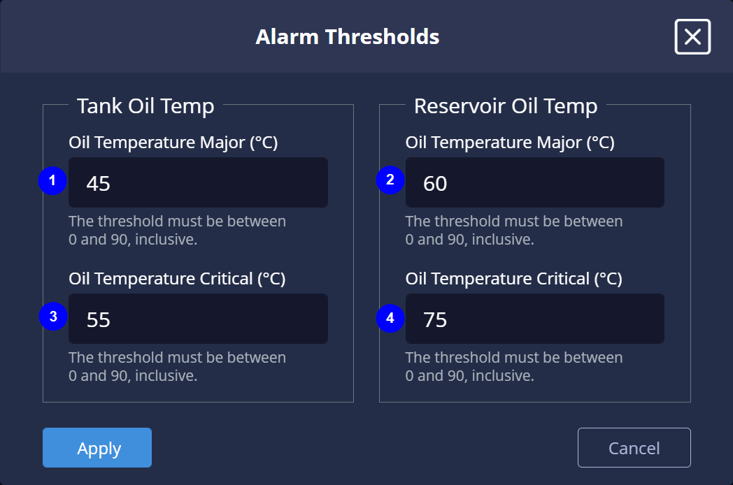*Figure 12*

Each of the numbered items is described in further detail below:

1. **Tank Oil Temp (Major) –** Set the maximum temperature (°C) for the Tank coolant above which a Major alarm will be triggered. Major alarms indicate a need for immediate action but do not start any failsafe mechanism such as cutting power to the Tank PDU receptacles. For more information about CryptoCore alarms see **Alarm Threshold Parameter Values** and **CryptoCore OTTOcontrol Alarm Types**.
2. **Reservoir Oil Temp (Major) –** Set the maximum temperature (°C) for the Tank reservoir coolant above which a Major alarm will be triggered.
3. **Tank Oil Temp (Critical) –** Set the maximum temperature (°C) for the Tank coolant above which a Critical alarm will be triggered. Critical alarms indicate a need for immediate action and cut power to the Tank PDU receptacles to prevent possible damage to the miner hardware and / or to mitigate the risk of a potentially dangerous situation. For more information about CryptoCore alarms see **CryptoCore Dashboard Status**.
4. **Reservoir Oil Temp (Critical) -** Set the maximum temperature (°C) for the Tank reservoir coolant above which a Critical alarm will be triggered. Critical alarms indicate a need for immediate action and cut power to the Tank PDU receptacles to prevent possible damage to the miner hardware and / or to mitigate the risk of a potentially dangerous situation. For more information about CryptoCore alarms see **CryptoCore Dashboard Status**.

#### 1.1.6.3 System Properties

Select **Settings** and then **System Properties** to configure the Tank Fluid type and Time settings for your CryptoCore unit.

1. Select the **Fluid Type** dropdown to specify the type of tank fluid for your unit. Choices include:
   * **Engineered Fluids BC-888**
   * **Cargill NatureCool 1000**
   * **Shell S3X**
   * **Other**

**Note**

Ensure that you specify the correct Tank fluid type for your miner hardware. Different dielectric cooling fluids have different performance characteristics. Do not risk damaging your miner hardware by immersing it in a fluid that has not been tested and certified for use with your miners.

1. Select the **Time Zone** that your CryptoCore unit will be in when deployed.
2. If you prefer to have time set automatically, enable **Set time automatically (NTP)**, highlighted in red below.
3. If you enable automatic time configuration, provide valid NTP Server addresses (such as described at [**https://www.ntppool.org/**](https://www.ntppool.org/)) for the CryptoCore unit to retrieve time configuration data from.
4. Click **Apply** to save your changes.

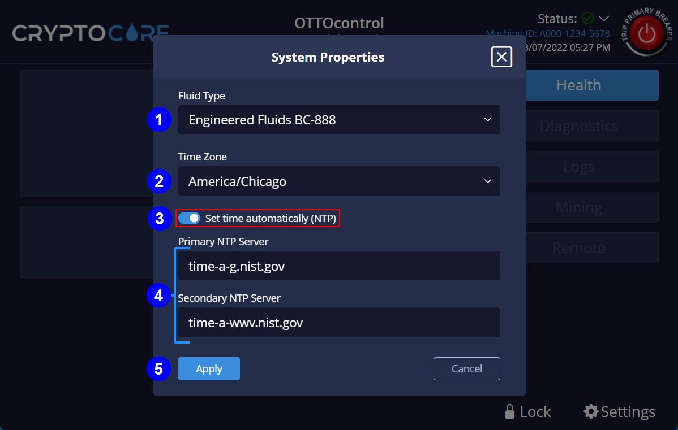

*Figure 13*

1. You can also configure unit time manually from the **System Properties** dialog box. After you specify the right fluid type for your unit, disable the **Set time automatically (NTP)** option, and enter appropriate values for **Time Zone**, **Date** and **Time**.

Click **Apply** to save your changes.

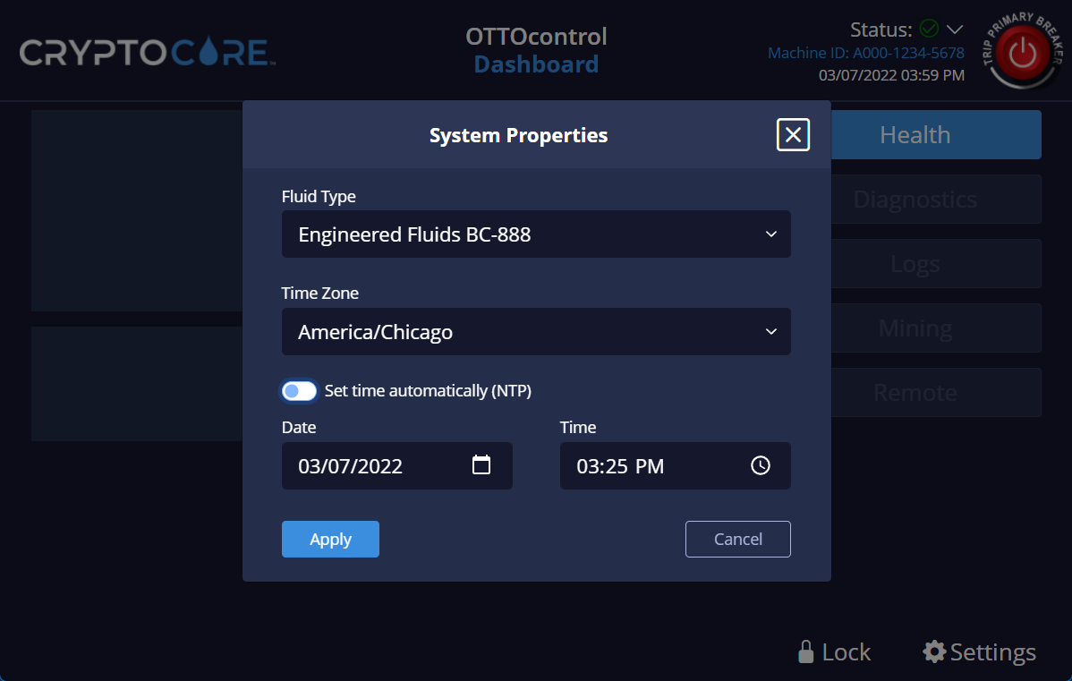*Figure 14*

#### 1.1.6.4 Lockscreen Password

User access to the CryptoCore Dashboard is governed through password authentication. Users that authenticate with the correct password to unlock the dashboard can access the Dashboard to monitor and manage the CryptoCore unit. Select the **Lockscreen Password** setting to display the Lockscreen Password dialog box:

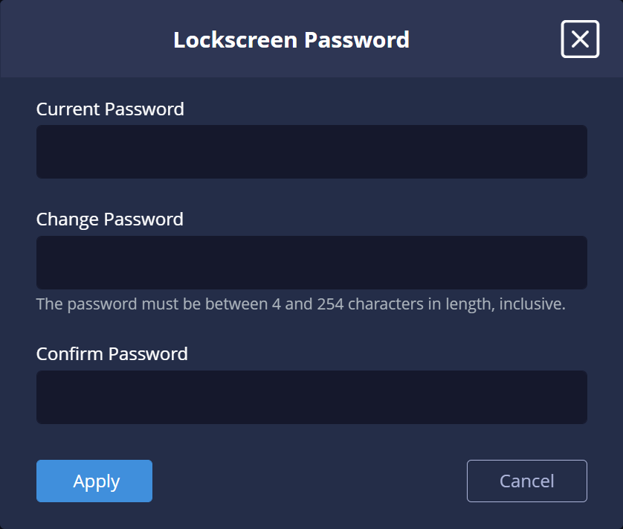

*Figure 15*

Use this dialog box to enter a new or change an existing password for user access to the CryptoCore Dashboard. Click **Apply** to save your changes.

**Note**

The password is subject to the following restrictions:

* Password values can use any combination of the following character set:

a-z,A-Z,0-9,!@#$%^&*()-=[];',./+_{}|:"?`~

* The password must be at least 4 characters
* The password must be less than 254 characters, any characters entered beyond 254 are truncated.

#### 1.1.6.5 System Information

Select **Settings** and then **System Information** to view system information for your CryptoCore unit. System information includes the unique Serial number of your unit as well as information about electrical requirements, tank cooling fluid, water pumping capacity and details about when and where the unit was built.

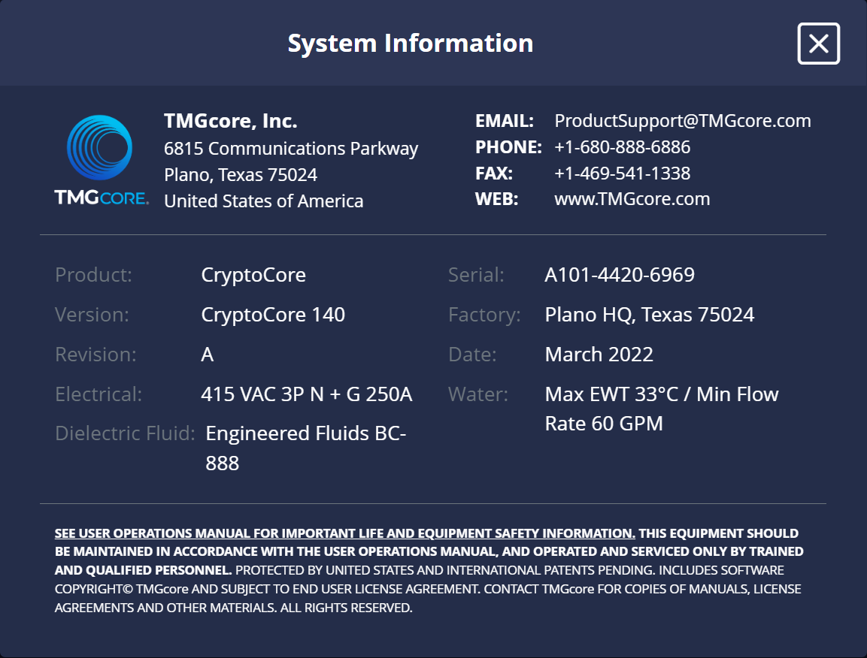

*Figure 16*

**Note**

The **Version:** displayed on this page is specific to the unit type and designates if the unit is a **CryptoCore 140** or a **CryptoCore 200**.

## 2.0 Hardware Stack

The CryptoCore OTTOcontrol hardware stack runs on a Raspberry PI Model B with 4 GB of RAM. The following illustration highlights the major components of the OTTOcontrol hardware stack (forward and reverse images depicted):

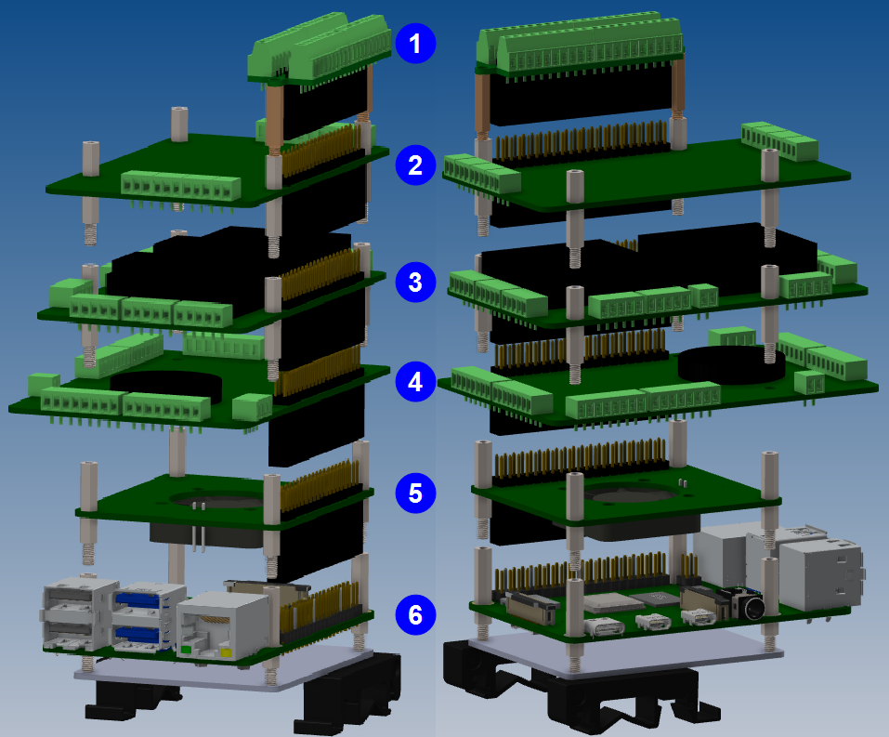*Figure 17*

### 2.0.1 Hardware Details

Each of the numbered items in Figure 22 is described in further detail below:

1. **CZH-Labs Ultra-small RPi GPIO Terminal Block Breakout Board Module** – This unit is used to connect to and facilitate communication with the CryptoCore LED strip. For more information see [**RPi Terminal Block Breakout Board Module**](https://czh-labs.com/products/ultra-small-rpi-gpio-terminal-block-breakout-board-module-for-raspberry-pi).
2. **Sequent Microsystems RTD Data Acquisition HAT** – This unit receives data from various temperature sensor inputs distributed throughout the CryptoCore unit. For more information see [**RTD Data Acquisition HAT**](https://sequentmicrosystems.com/collections/all-io-cards/products/rtd-data-acquisition-card-for-rpi).
3. **Sequent Microsystems Eight Relay HAT** – This unit handles dry contact mechanisms on the CryptoCore unit and sends the appropriate actions to the PDU. For more information see [**Eight Relay HAT**](https://sequentmicrosystems.com/collections/all-io-cards/products/raspberry-pi-relays-stackable-card?variant=37993168732355).
4. **Sequent Microsystems Industrial Automation HAT** – This unit provides various electrical interfaces to communicate with sensors and digital I/O. For more information see [**Industrial Automation HAT**](https://sequentmicrosystems.com/collections/all-io-cards/products/industrial-raspberry-pi)
5. **Sequent Microsystems Smart Fan HAT** – This unit is the cooling solution used for the Raspberry Pi CPU, for more information see [**Smart Fan HAT**](https://sequentmicrosystems.com/collections/all-io-cards/products/raspberry-pi-fan?variant=37993169256643).
6. **Raspberry Pi 4 Model B with 4 GB Ram** – This unit supplies the computing and storage requirements for the OTTOcontrol software stack. The operating system is Ubuntu Linux 20.04 which hosts several software components including services for NODE Red and Redis, programming logic for processing various I/O and the front-end software for the Human Machine Interface (HMI). For more information about the Raspberry PI 4 model B see [**Raspberry Pi 4**](https://www.raspberrypi.com/products/raspberry-pi-4-model-b/).

### 2.0.2 Raspberry Pi I/O

The Raspberry Pi 4 provides multiple interfaces for connecting to external devices. The following diagram depicts a Raspberry Pi 4 as viewed from underneath:

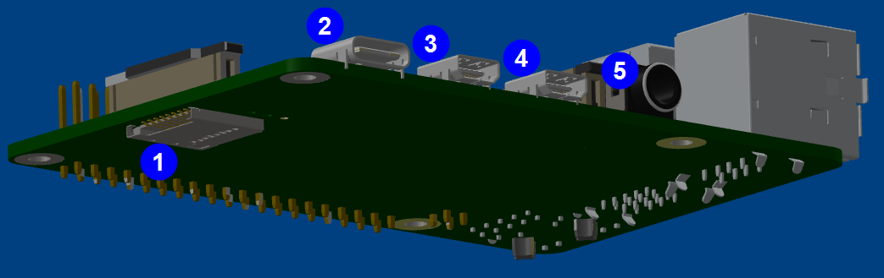

*Figure 18*

Each of the numbered items in Figure 23 is described in further detail below:

1. **MicroSD slot** – Accepts a MicroSD card to house the Raspberry Pi file system.
2. **USB-C Power supply input** – Input for a 15W USB-C power supply.
3. **Micro HDMI port** – Provides connectivity to a 4K display.
4. **Micro HDMI port** – Provides connectivity to a 4K display.
5. **Audio-video port** – 3.5 mm analog audio-video jack.

The following diagram depicts a Raspberry Pi 4 as viewed from the top:

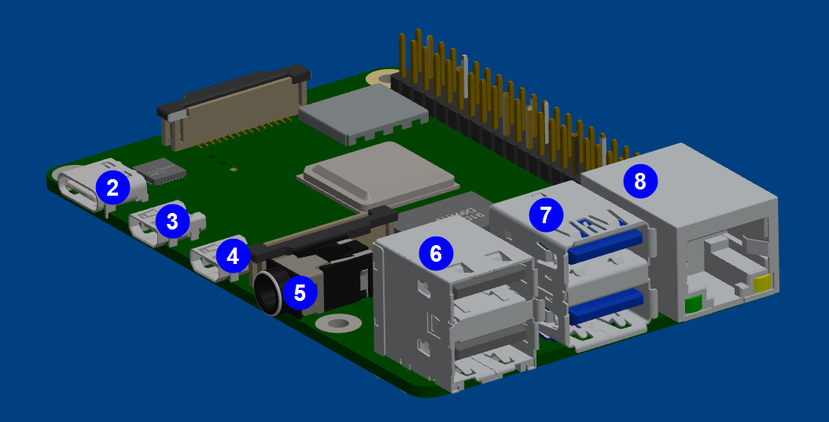

*Figure 19*

Each of the numbered items in Figure 24 is described in further detail below:

1. **USB-C Power supply input** – Used to connect a 15W USB-C power supply.
2. **Micro HDMI port** – Provides connectivity to a 4K display.
3. **Micro HDMI port** – Provides connectivity to a 4K display.
4. **Audio-video port** – 3.5 mm analog audio-video jack.
5. **USB 2.0 ports** – 2 USB 2.0 ports
6. **USB 3**.**0 ports** – 2 USB 3.0 ports
7. **Ethernet port** – Gigabit ethernet port

### 2.0.3 PDU Master Switch

All CryptoCore units include a manual PDU Master switch mounted on the top of the unit. The PDU Master switch has three positions, **On**, **Trip** and **Off**. If a Critical Alarm occurs on the CryptoCore unit, the PDU Master switch is tripped and power to the tank PDU receptacles is cut. The PDU Master switch is depicted in Figure 25 below:

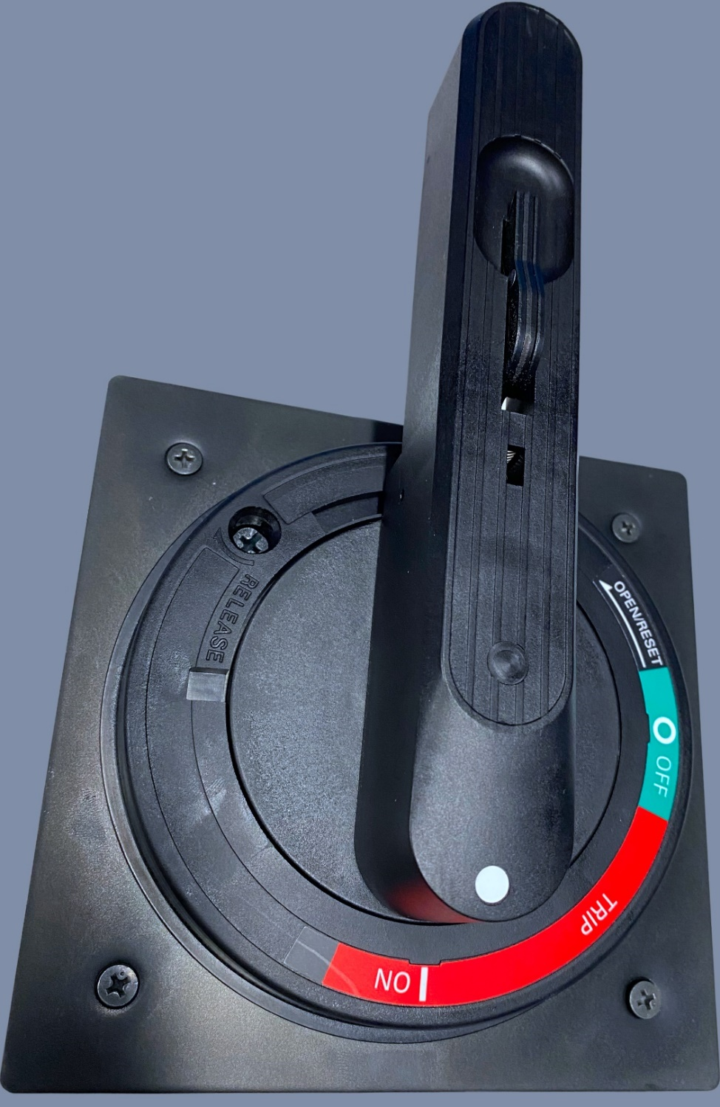

*Figure 20*

**Note**

The depicted PDU Master Switch is for a CryptoCore 200, the CryptoCore 140 uses a similar switch without the handle.

## 3.0 Troubleshooting

This section describes available tools for diagnosing and troubleshooting potential problems with your CryptoCore unit.

### 3.0.1 System State and LED State

CryptoCore units employ a combination of LED lights and Alarm indicators to convey System State and Alarm status. System State indicates if a CryptoCore unit can perform data processing and Alarm indicators provide details about potential problematic conditions. CryptoCore System State and Alarm status values are summarized below:

|  |  |  |  |  |
| --- | --- | --- | --- | --- |
| **LED State** | **System State** | **Trigger** | **Meaning / System response** | **OTTOcontrol Alarm Severity** |
| Off | Powered down | Power disconnected from unit, PDU Master Switch has been engaged or Primary Breaker has been tripped via OTTOcontrol software. | The system is powered down. | N/A |
| White | Powered up with miners off | Power**–**up complete, Tank PDU receptacles off. | Power up complete and PDU Master switch is in the Off position. Tank PDU receptacles have no power. | N/A |
| White | PDU breaker tripped | Tank PDU breaker tripped, power cut to Tank PDU receptacles. PDU breaker can be tripped by overcurrent or by critical alarm. | Tank PDU breaker has tripped and cut power to the Tank PDU receptacles. Investigate and resolve the issue. PDU Master switch that is mounted on the tank must be reset manually. | N/A |
| Blue | Powered up with miners running. | Power up completed successfully and Tank PDU receptacles are on. | Power up complete and PDU Master switch is in the On position. Tank PDU receptacles have power. | N/A |

*Table 3*

**System State, LED State and Alarms (cont.)**

|  |  |  |  |  |
| --- | --- | --- | --- | --- |
| **LED State** | **System State** | **Trigger** | **Meaning / System response** | **OTTOcontrol Alarm Severity** |
| Red | Idle | Major alarm triggered | System requires immediate attention. If the issue is not addressed quickly then an interruption to service may occur or a hazardous condition may arise, which poses a risk to safety. | **Major** |
| Red Flashing | Critical Alarm active | Critical Alarm triggered | System requires immediate attention to address a service disruption and / or a condition which poses a safety risk. When a critical alarm occurs, the power to the Tank PDU receptacles is cut and the PDU Master switch is open or ‘tripped’. The PDU Master switch must be manually reset to restore power to the Tank PDU receptacles.  A critical alarm is also generated and power to the Tank PDU receptacles is cut when the **Trip Primary Breaker** button is clicked from the CryptoCore OTTOcontrol HMI as described in **Trip Primary Breaker**. | **Critical** |

*Table 3* *(cont.)*

## Addendum A – Software Installation and Upgrade

For information about installing software on your Raspberry Pi see [**Install CryptoCore OTTOcontrol on a Raspberry Pi**](https://tmgcore0.sharepoint.com/:w:/s/TMGcoreInternalSharePoint/Ecx6Q1nO05tAj5oHcBBtUnYB1LdE4e685LBRffTZlRlrqg?e=84ETah).

## Addendum B – Intellectual Property Rights

Unless otherwise indicated, this documentation is TMGcore, Inc. proprietary information and all functionality, software, text, and graphics in this document and the trademarks, service marks, and logos contained therein are owned or controlled by us or licensed to us and are protected by copyright and trademark laws and various laws and various other intellectual property rights and unfair competition laws of the United States, foreign jurisdictions, and international conventions. The Content is provided in this document “AS IS” for your information and personal use only. Except as expressly provided in these Terms of Use, no part of this document may be copied, reproduced, aggregated, republished, uploaded, posted, publicly displayed, encoded, translated, transmitted, distributed, sold, licensed, or otherwise exploited for any commercial purpose whatsoever, without express prior written permission.